**Exercise 1: Setting Up Junit**

**Calculator.java**

package com.example;

public class Calculator {

public int add(int a, int b) {

return a + b;

}

}

**CalculatorTest.java**

package com.example;

import org.junit.Test;

import static org.junit.Assert.*;

public class CalculatorTest {

@Test

public void testAdd() {

Calculator calc = new Calculator();

assertEquals(5, calc.add(2, 3));

}

}

**Output:**

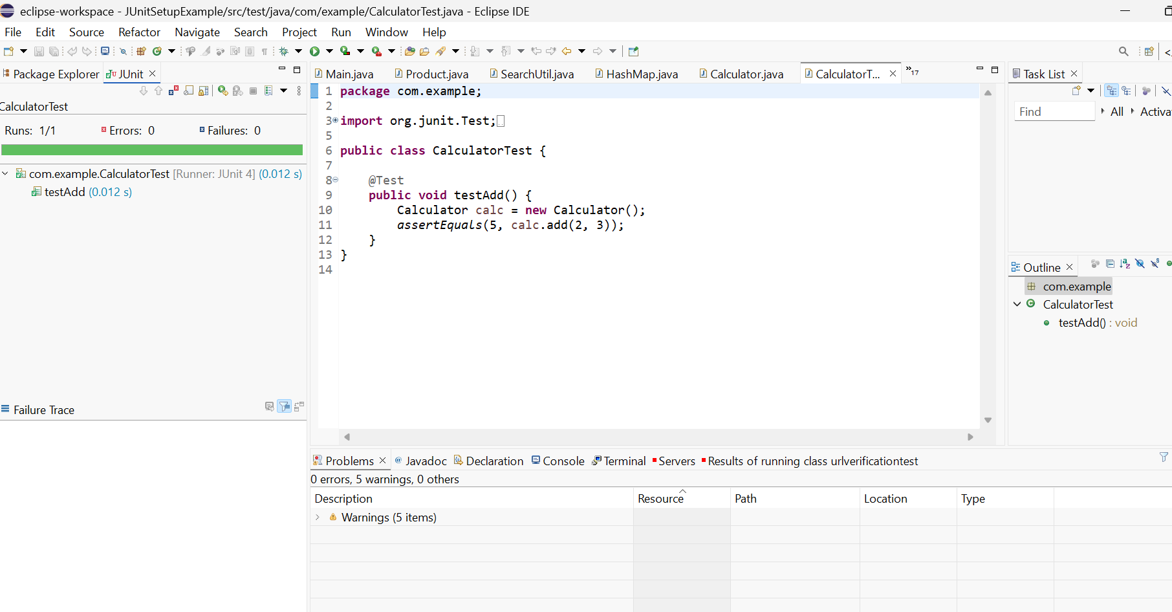

**Exercise 3: Assertions in Junit**

**AssertionsTest.java**

**package com.example;**

**import org.junit.Test;**

**import static org.junit.Assert.*;**

**public class AssertionsTest {**

**@Test**

**public void testAssertions() {**

**// Assert equals**

**assertEquals(5, 2 + 3);**

**// Assert true**

**assertTrue(5 > 3);**

**// Assert false**

**assertFalse(5 < 3);**

**// Assert null**

**assertNull(null);**

**// Assert not null**

**assertNotNull(new Object());**

**}**

**}**

**Output:**

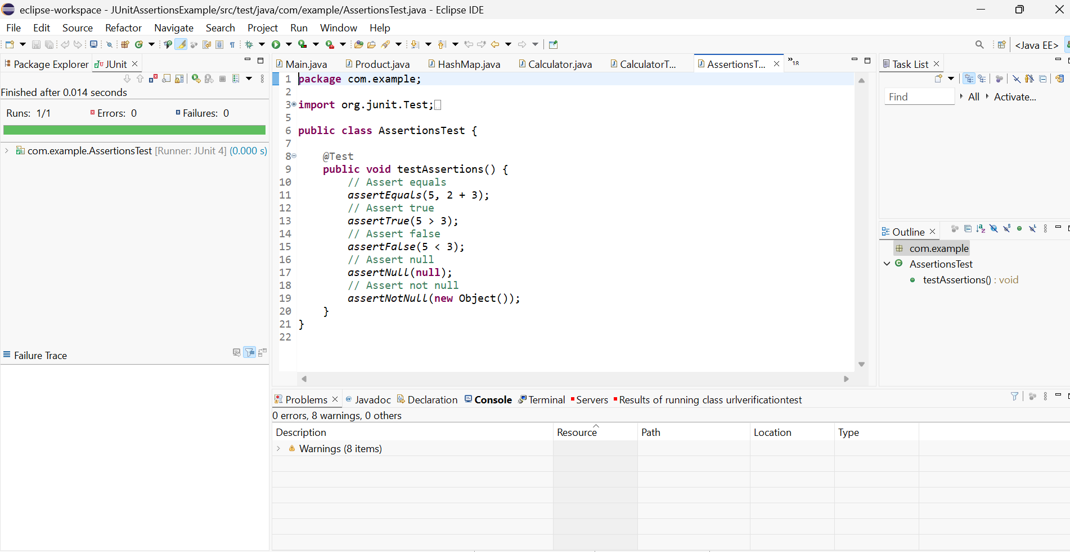

**Exercise 4: Arrange-Act-Assert (AAA) Pattern, Test Fixtures, Setup and Teardown Methods in Junit**

**CalculatorAAATest.java**

**package com.example;**

**import org.junit.Before;**

**import org.junit.After;**

**import org.junit.Test;**

**import static org.junit.Assert.*;**

**public class CalculatorTest {**

**private Calculator calculator;**

**@Before**

**public void setUp() {**

**System.out.println("Setting up...");**

**calculator = new Calculator(); // Arrange**

**}**

**@After**

**public void tearDown() {**

**System.out.println("Tearing down...");**

**calculator = null;**

**}**

**@Test**

**public void testAdd() {**

**// Act**

**int result = calculator.add(4, 6);**

**// Assert**

**assertEquals(10, result);**

**}**

**@Test**

**public void testMultiply() {**

**// Act**

**int result = calculator.multiply(3, 5);**

**// Assert**

**assertEquals(15, result);**

**}**

**}**

**Output:**

